1. Create a S3 bucket, with no public access and upload files to the bucket

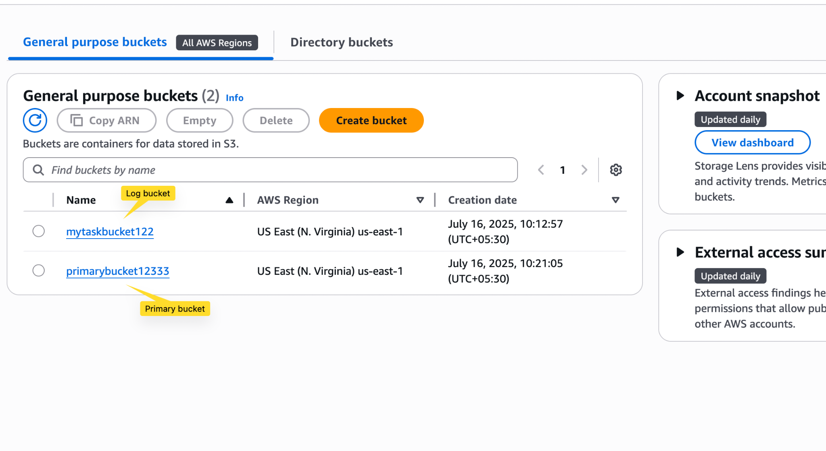

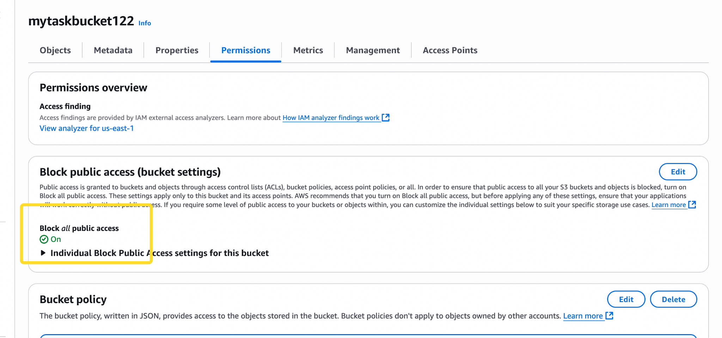

view the logs using cloudwatch for the uploaded files.

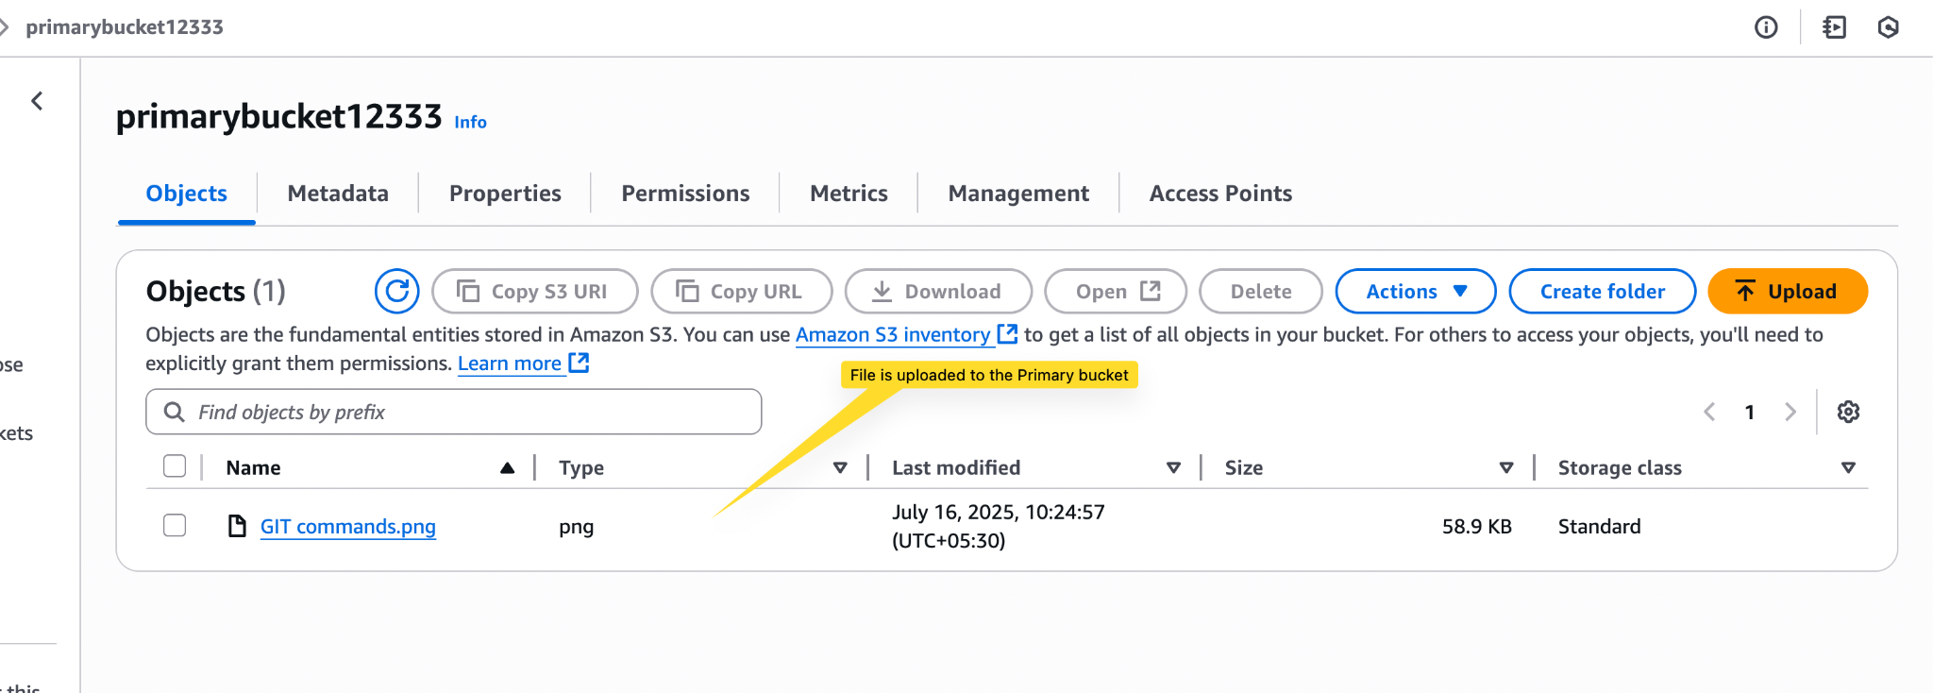

s3 is used to log the activity

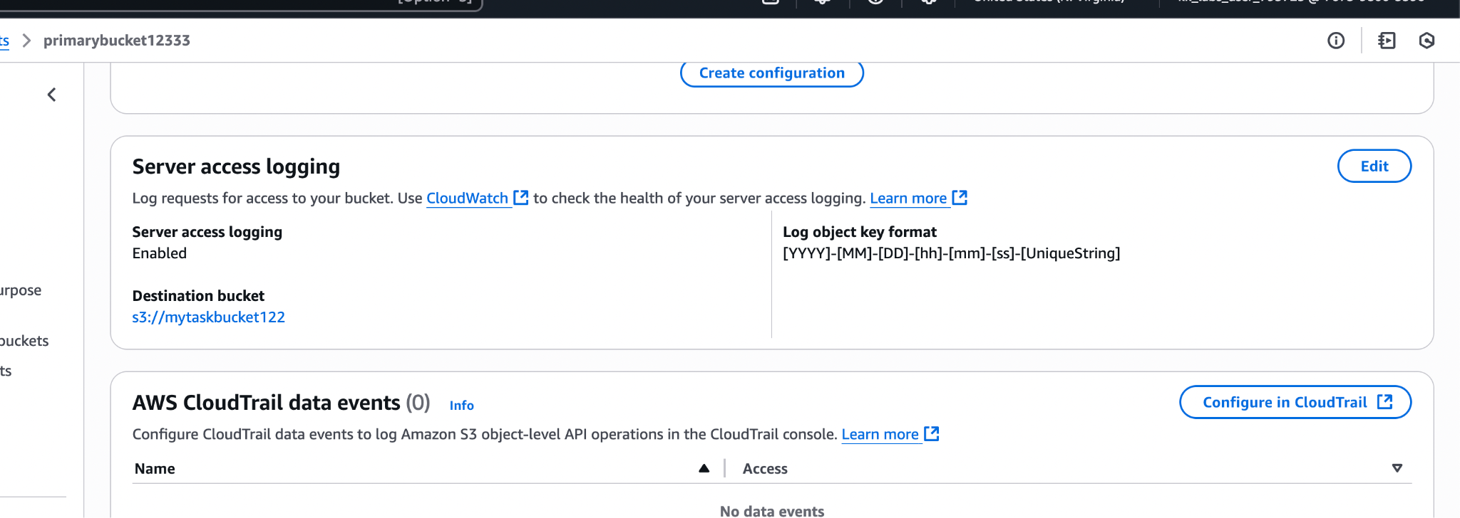

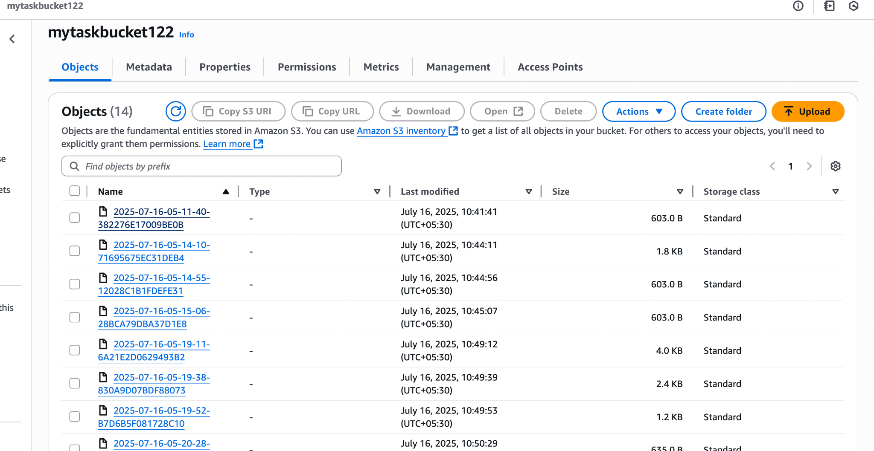

2.Launch two ec2-instances and connect it to a application load balancer, where the output traffic from the server must be an load balancer IP address

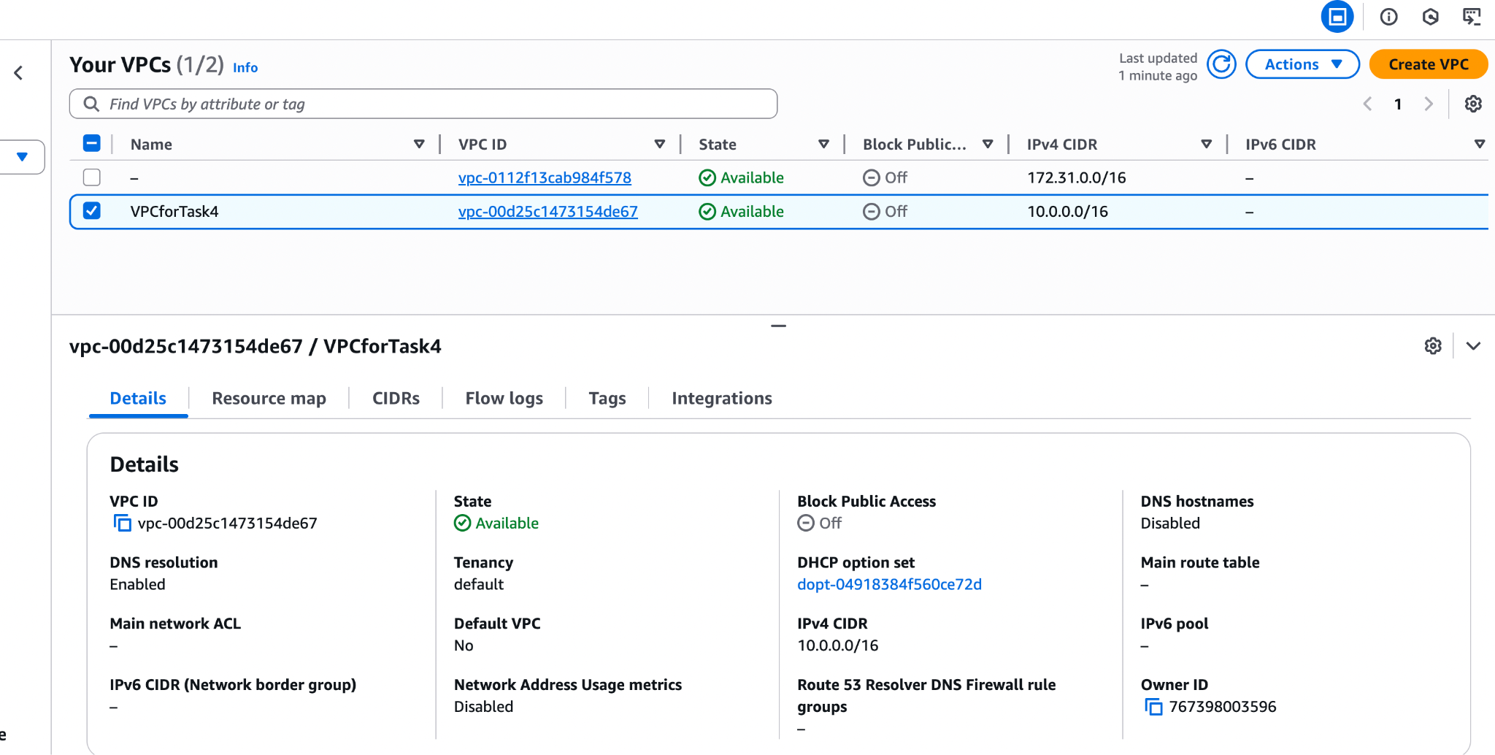

Creating Subnet

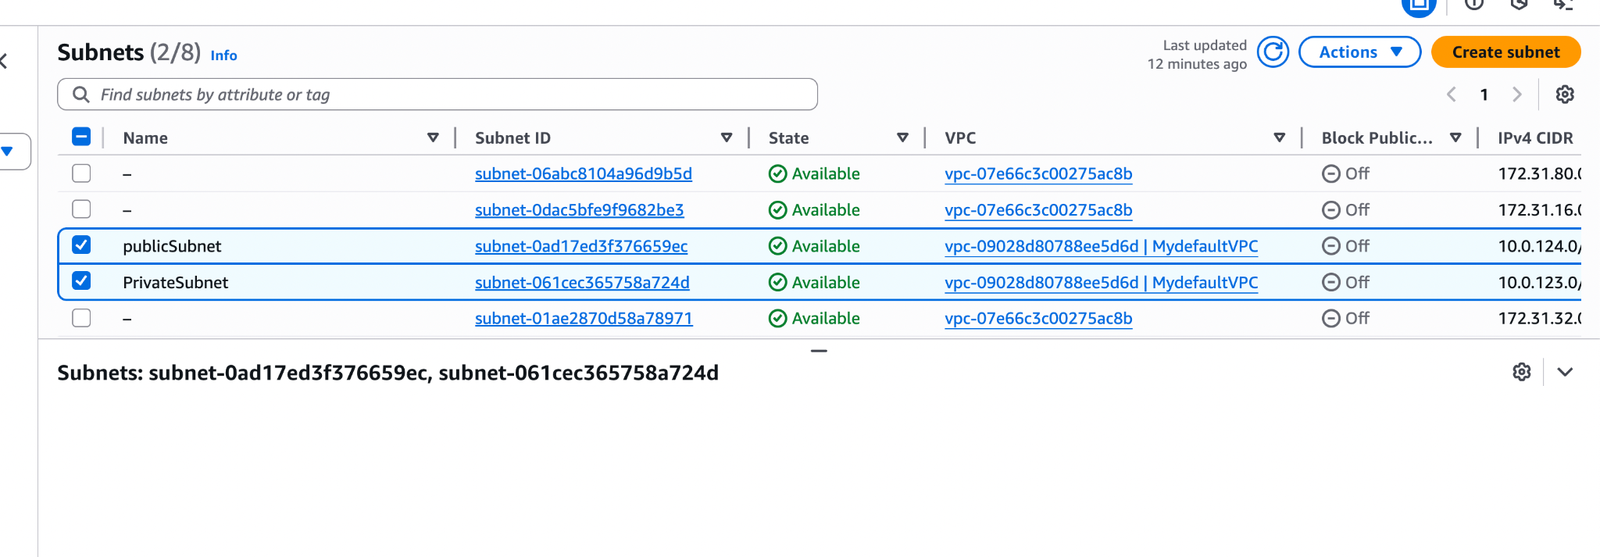

Launch two ec2-instances

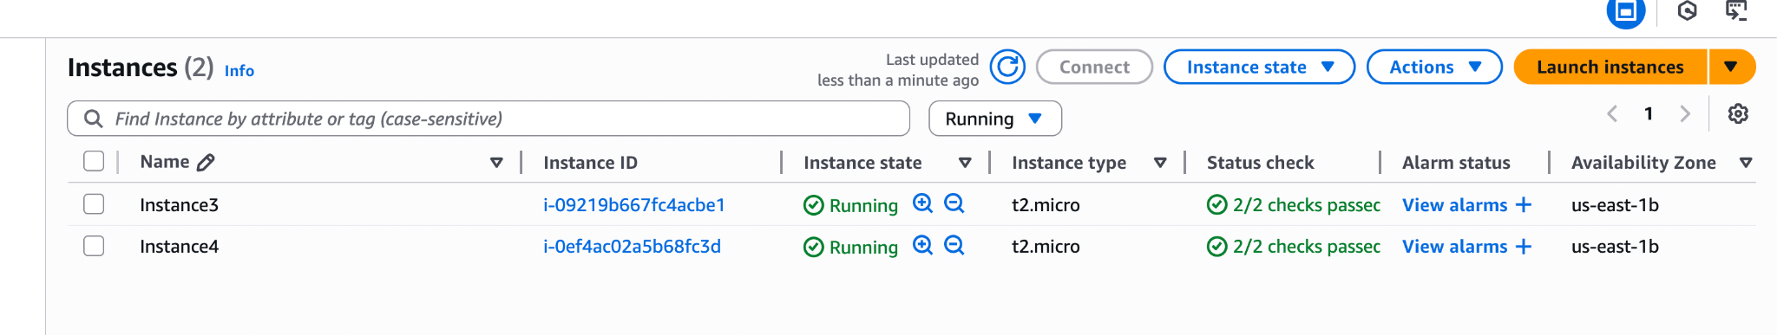

connect it to a application load balancer,

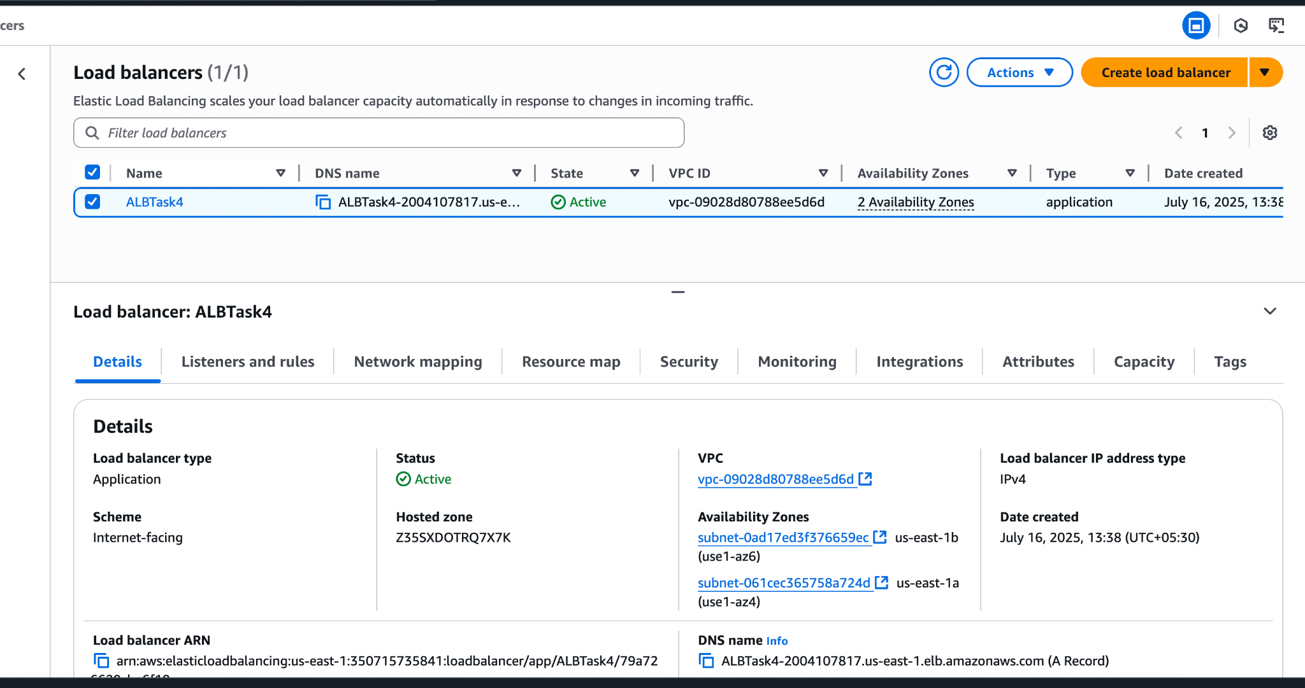

where the output traffic from the server must be an load balancer IP address

